Fixing Plastic Sheeting to Wood | Fixing to Rope
  ✗ | ✓
  Nail will tear sheet | bending nails, using washers or bottle caps is better | ✓✓
  ✗ | ✓ | Double fold sheet over wood before fixing
  Too close to edge | Fold sheet over wood before fixing
  ✗ Fixtures too far | ✓ fixtures 6”-12” apart
  ✗
  no reinforcement
  ✓
  rope through eyelet
  ✓✓
  rope through reinforcement band
  ✓✓
  place stone inside
  ✓✓
  make knot with rope inside

Fixing Plastic Sheeting to Bamboo
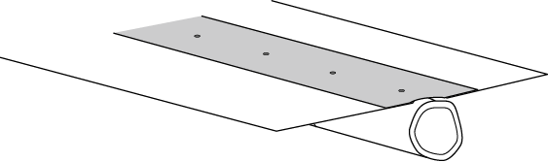
✗ nailed straight through plastic
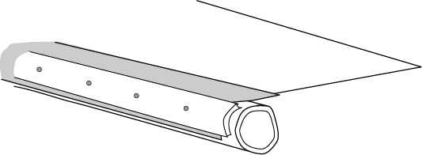 |  | 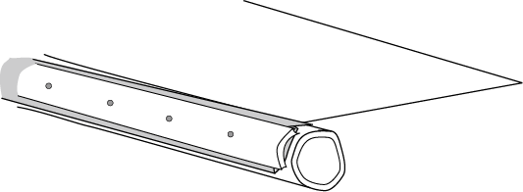
✓ wired (better) or nailed through section of bamboo |  | ✓✓ plastic sheeting folded over then wired (better) or nailed through section of bamboo
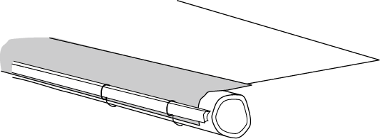 |  | 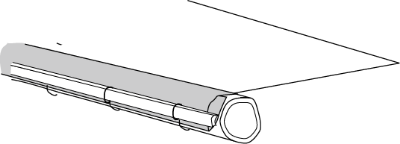
✓ wire looped around batten passed through hole in the sheet and wrapped around the pole |  | ✓✓ plastic sheet folded back on itself, then wire looped around batten passed through hole in the sheet and wrapped around the pole

